**Project: Accessing and updating a Staff table**

Problem Description:

Write a Java GUI program that views, inserts, and updates staff information stored in a database, as shown in the following figure. The view button displays a record with a specified ID. The Staff table is created as follows:

**create table** Staff (

id **char**(9) **not null**,

lastName **varchar**(15),

firstName **varchar**(15),

mi **char**(1),

address **varchar**(20),

city **varchar**(20),

state **char**(2),

telephone **char**(10),

email **varchar**(40),

**primary key** (id)

);

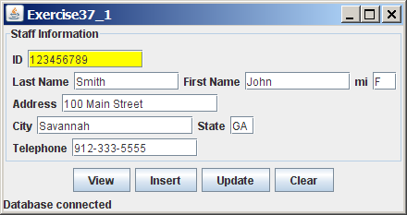

**Users Guide:**

1. Create a folder titled “lib” in the Java project. Add the .jar files from Blackboard into the folder.
2. Right click on the project name in the left sidebar in Eclipse. Go to Build Path > Configure Build Path.
3. Select Add External JARs on the right. When the new window appears select the JAR files in the lib folder. Click OK.

4. That should be it. The program will create the table if it doesn’t already exist.

**Screen shot:**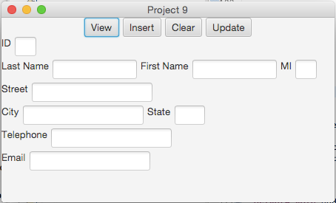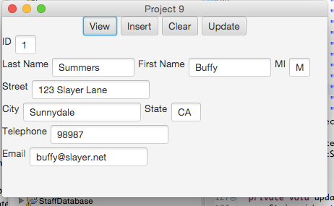

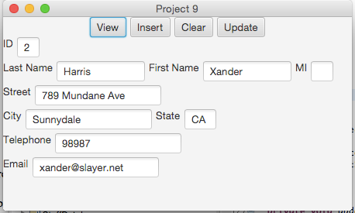

**UML**

2. Fill in self-evaluation:

1. Is your database created correctly? Yes
2. Can you create the UI? Yes
3. Can you connect to the database? Yes
4. Is the View button implemented correctly? Yes
5. Is the Insert button implemented correctly? Yes
6. Is the Update button implemented correctly? Yes
7. Is the Clear button implemented correctly? Yes